|  |  |
| --- | --- |
|  | **FPT ACADEMY INTERNATIONAL**  **FPT – APTECH COMPUTER EDUCATION** |

**JamesThewDOTcom**

**Installation Guide**

|  |  |  |
| --- | --- | --- |
| **Supervisor:** | Mr. Le Thanh Nhan | |
| **Semester:** | 3 | |
| **Batch No:** | T1.2208.M2 | |
| **Group No:** | 1 | |
| **Order:** | **Full name** | **Roll No.** |
| 1. | *Bui Tran Anh Tri* | *Student1414230* |
| 2. | *Pham Tien Duc* | *Student1414248* |
| 3. | *Hoang Ngoc Phu* | *Student1396925* |
| 4. | *Nguyen Hoang Trung* | *Student1414357* |

December 2023

# A. SYSTEM REQUIREMENTS:

* Hardware:

|  |  |
| --- | --- |
| Component | Requirement |
| CPU | Processor type:  Pentium IV-compatible processor or faster  Processor speed:  Recommended: 2.0 GHz or faster |
| OS | Microsoft Windows XP or higher with IIS |
| Memory (RAM) | RAM:  Minimum: 512 MB  Recommended: 2 GB or more  Maximum: Operating system maximum |
| Hard Drive | Free space:  Minimum: 200 MB  Recommended: 50 GB or more  Maximum: Operating system maximum |

* Software:

|  |  |
| --- | --- |
| Component | Requirement |
| ASP.NET Core | Version .NET Core 3.1  Entity Framework Core 3.1.3 |
| RDBMS | Microsoft SQL Server Management Studio 18 |
| Microsoft Visual Studio | Microsoft Visual Studio 2019 |
| Web Browser | IE 8.0 , Firefox 3.0,Chrome or Higher….. |

# B. Program Installation

1. **Database Configuration:**
   1. **Step 1:** Download and Install SQL Server Management Studio (SSMS) follow the path: <https://learn.microsoft.com/en-us/sql/ssms/download-sql-server-management-studio-ssms?view=sql-server-ver16>
   2. **Step 2:** Open SQL Server Management Studio (SSMS)

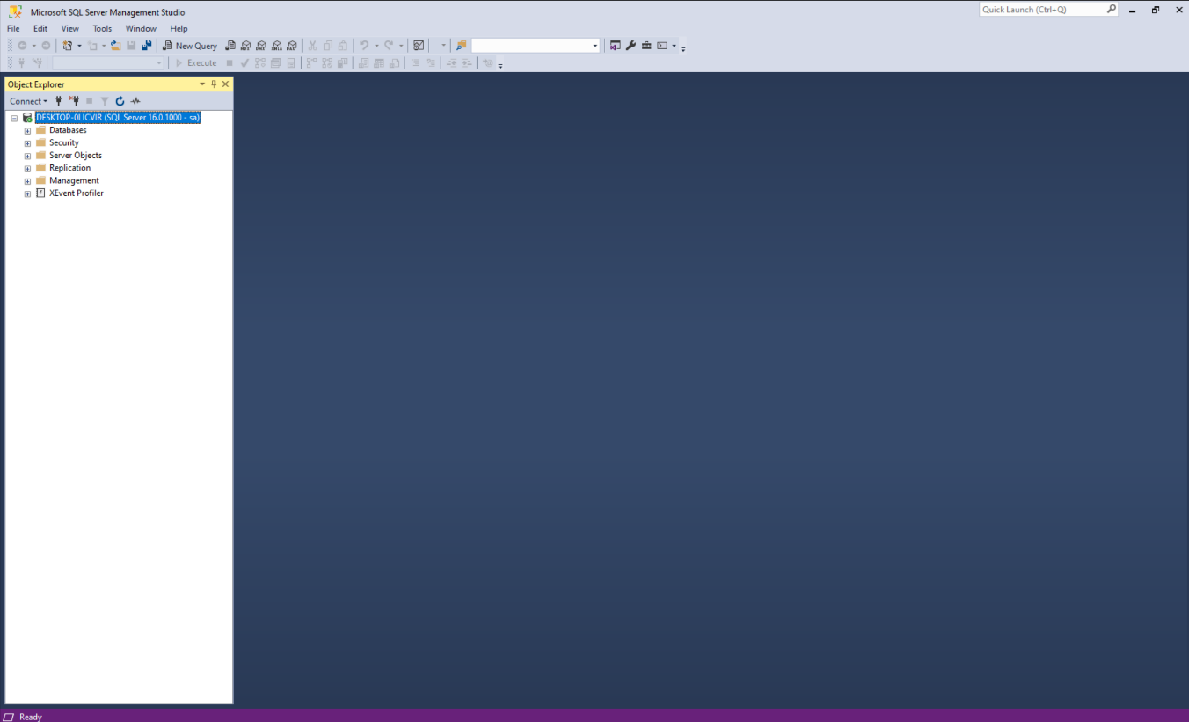

* 1. **Step 3:** Right click Database choose Restore Database…

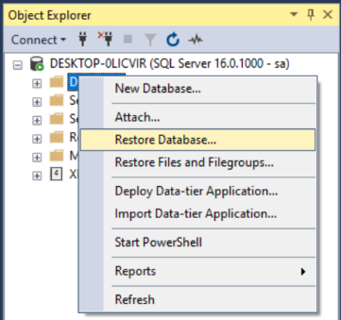

* 1. **Step 4:** Show Restore Database Table Choose Device and choose Brown (…)

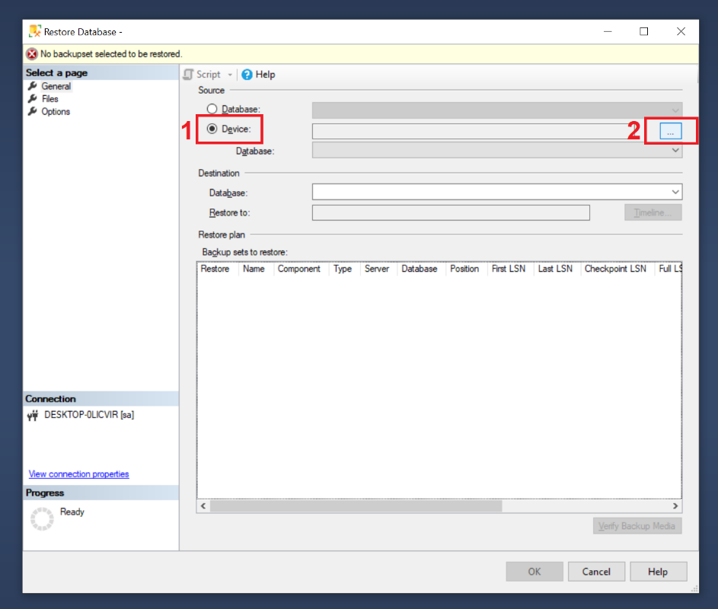

* 1. **Step 5:** Show Select backup device table choose Add

* 1. **Step 6:** Open and Connect Microsoft SQL Server Management Studio. Click New Query.

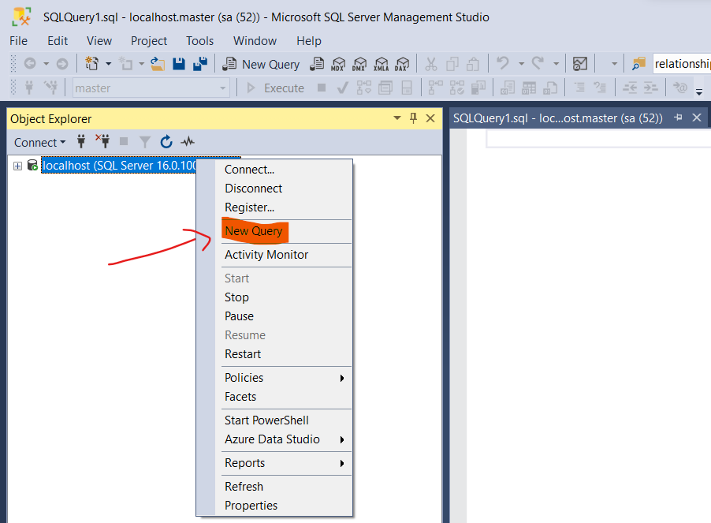

* 1. **Step 7:** Open folder *eProject/02.Developments/2.1.Database Script/.* Open JamesThewDOTcom database file by Microsoft SQL Server Management Studio
  2. **Step 8:** Press F5 key to insert database JamesThewDOTcom:
  3. **Step 9:** Refesh database. The name of database  ***“*JamesThewDOTcom*”*** will be displayed.

1. **Open Project**
   1. **Step 1:** Download and Install Microsoft Visual Studio 2022 follow the path: <https://visualstudio.microsoft.com/thank-you-downloading-visual-studio/?sku=Professional&channel=Release&version=VS2022&source=VSLandingPage&cid=2030&passive=false>

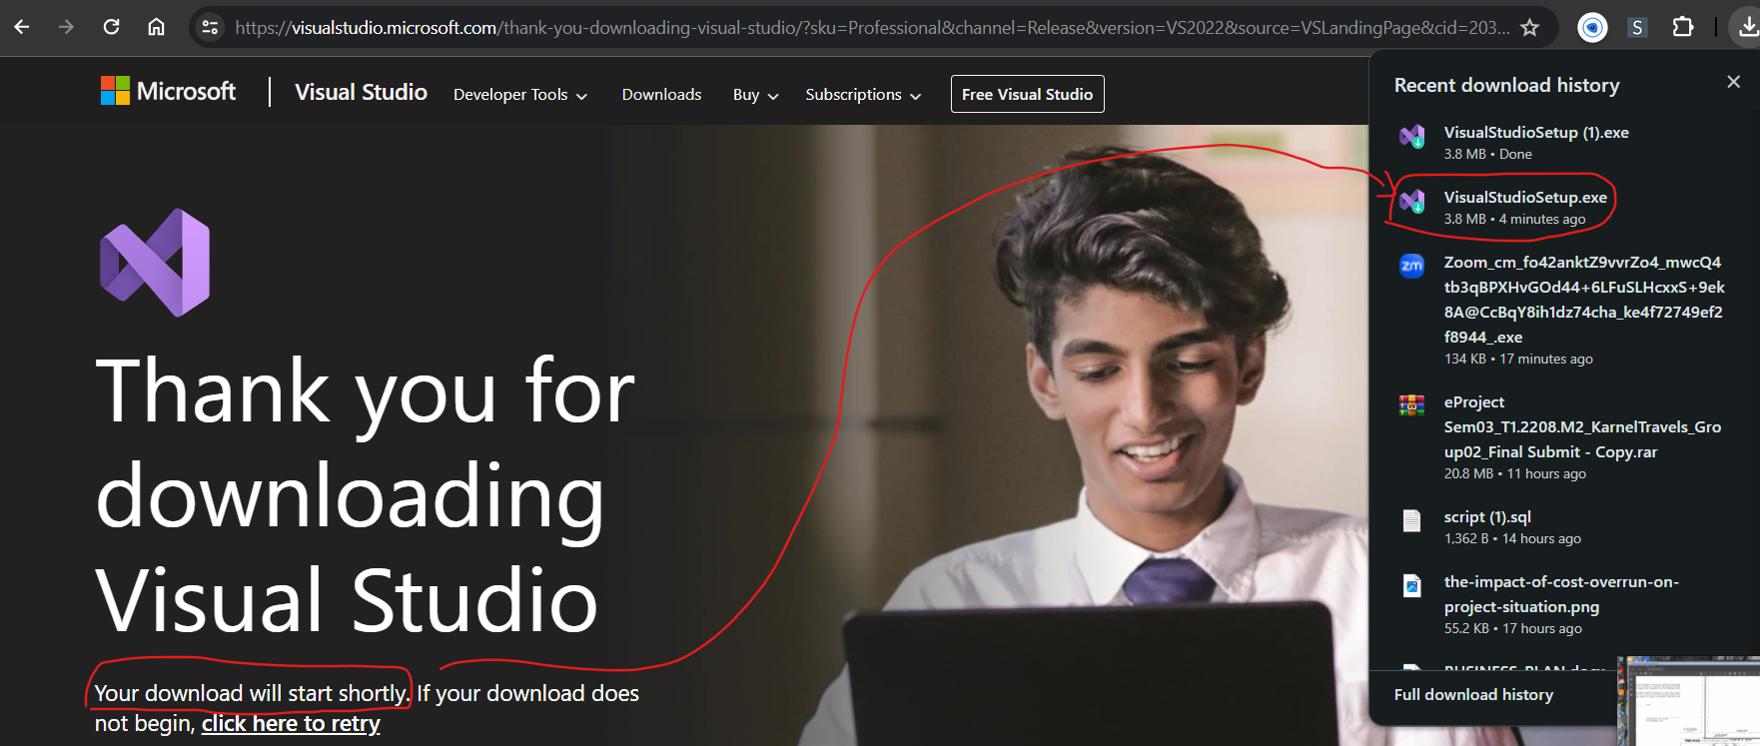

* 1. **Step 2:** Locate ***eProject*** solution file in *eProject/02.Developments/2.2.Source Code*/ folder.
  2. **Step 3:** Double-click on ***JamesRecipes.sln*** to open project in Microsoft Visual Studio

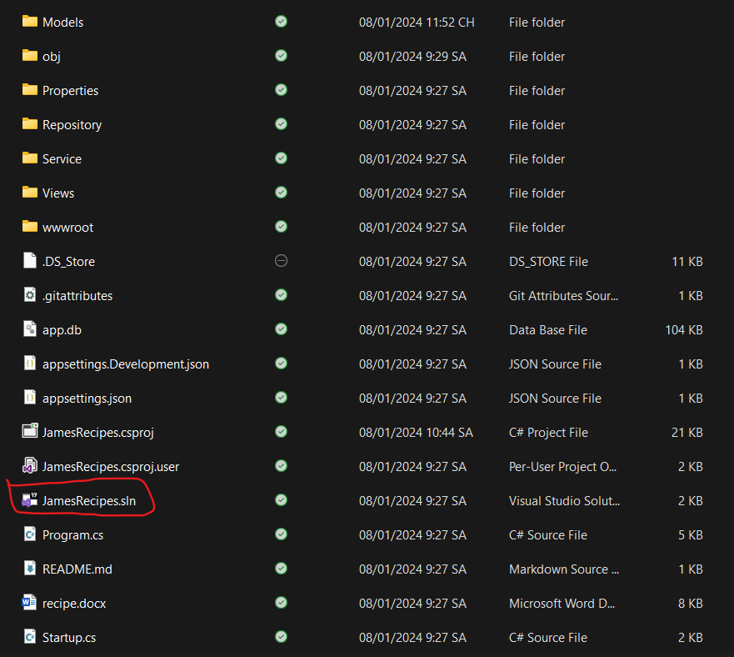

* 1. **Step 4:** Open *Microsoft SQL Server Management Studio* and copy Server name

* 1. **Step 5:** JamesRecipes on Microsoft Visual Studio open *Models/JamesrecipesContext.cs* file and paster Server Name

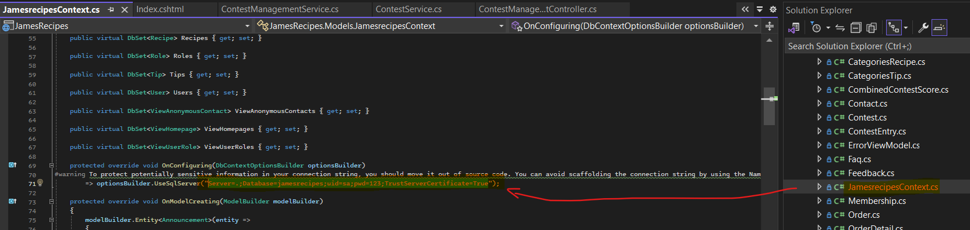

* 1. **Step 6:** In Microsoft Visual Studio, click on menu Build and select Build Solution. Wait for Successful message.
  2. **Step 7:** Click on IIS Express button and the website is ready.

# C. Successful test

So you have finished the installation of our software. Congratulations on that. We are very honored to be able to guide you, thank you for keeping track!!

Note: You can use the accounts below to test:

* Link to login admin: http://localhost:57649/admin/dashboard
  + **Admin ID:** admin
  + **Password:** 123



